**Graphical Representation**

1. **Histogram:**
2. **Box Plot:**
3. **Scatter Plot**

**Histogram:**

A histogram is a bar graph-like representation of data that buckets a range of classes into columns along the horizontal x-axis.

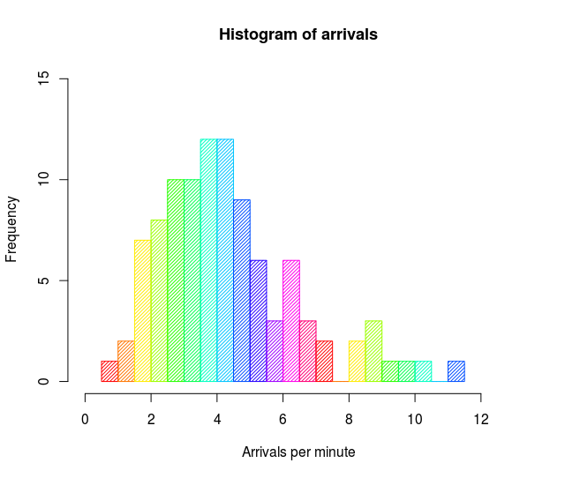

Steps to create a histogram:

- Sort the Number  
- Create Bins(Groups)  
- Plot the data on a Histogram basis of bins created

For example, a census focused on the demography of a town may use a histogram to show how many people are between the ages of 0 - 10, 11 - 20, 21 - 30, 31 - 40, 41 - 50, 51 -60, 61 - 70, and 71 - 80.

Graphical representation of the above data in Histogram

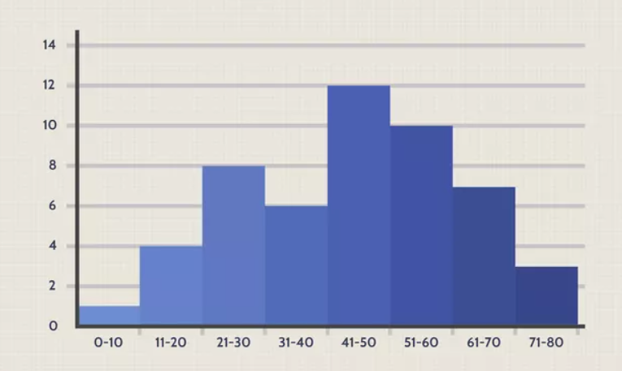

**Histogram for Discrete data:**

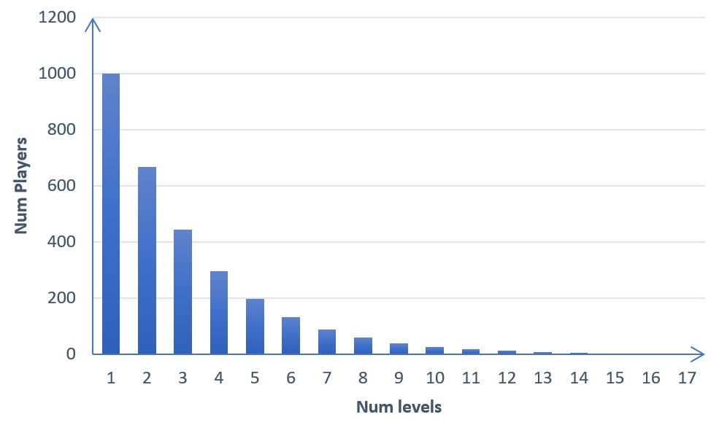

**5 number summary [Box Plot]:**

A five-number summary is especially used to remove outliers or during the preliminary investigation of a large data set. A summary consists of five values: the most extreme values in the data set (the maximum and minimum values), the lower and upper quartiles, and the median.

1. Minimum (Q0)
2. First Quartile (Q1)(25 Percentile)
3. Median (Q2) (50 Percentile)
4. Third Quartile (Q3) (75 Percentile)
5. Maximum (Q4) (100 Percentile)

Inter Quartile Range(IQR) = Q3 - Q1  
Lower Fence = Q1 - 1.5 * IQR  
Higher Fence = Q3 + 1.5 * IQR

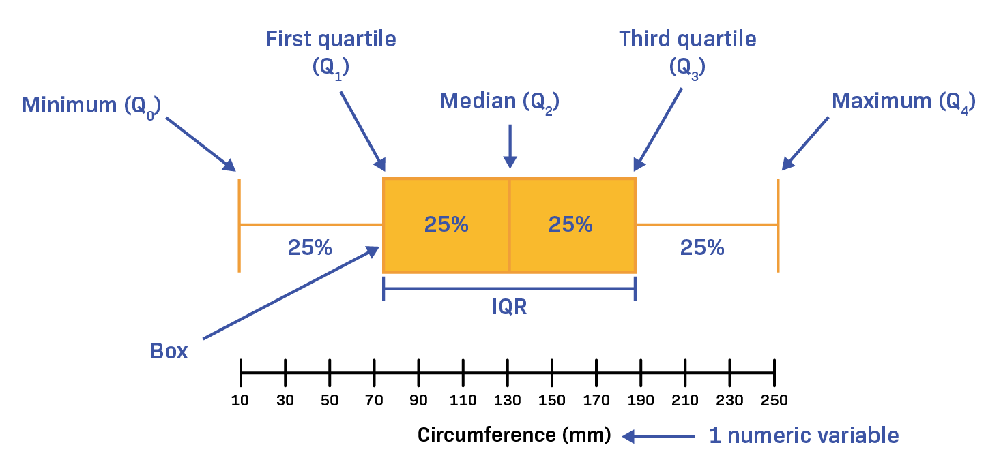



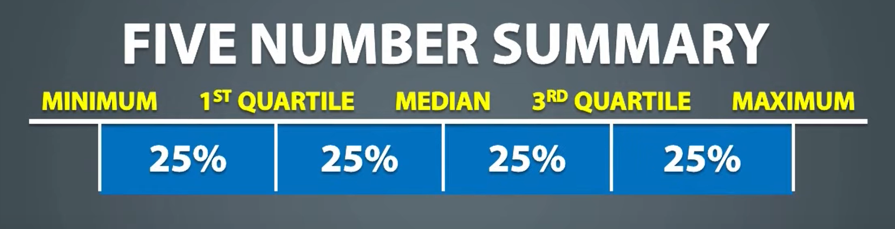



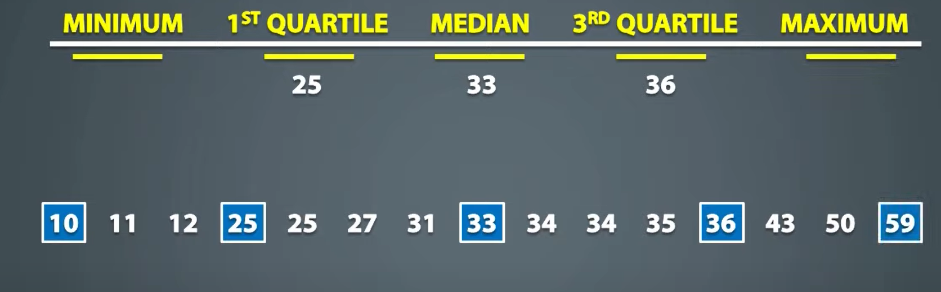

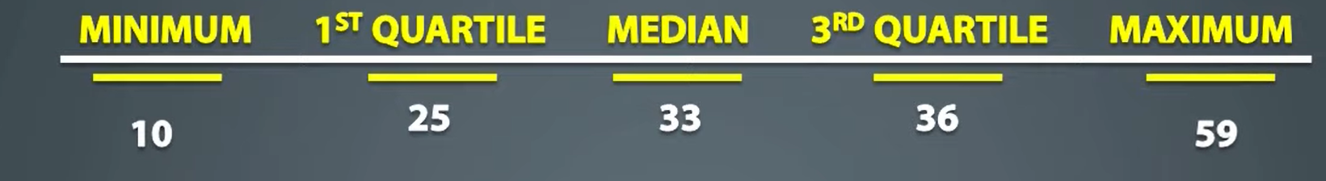

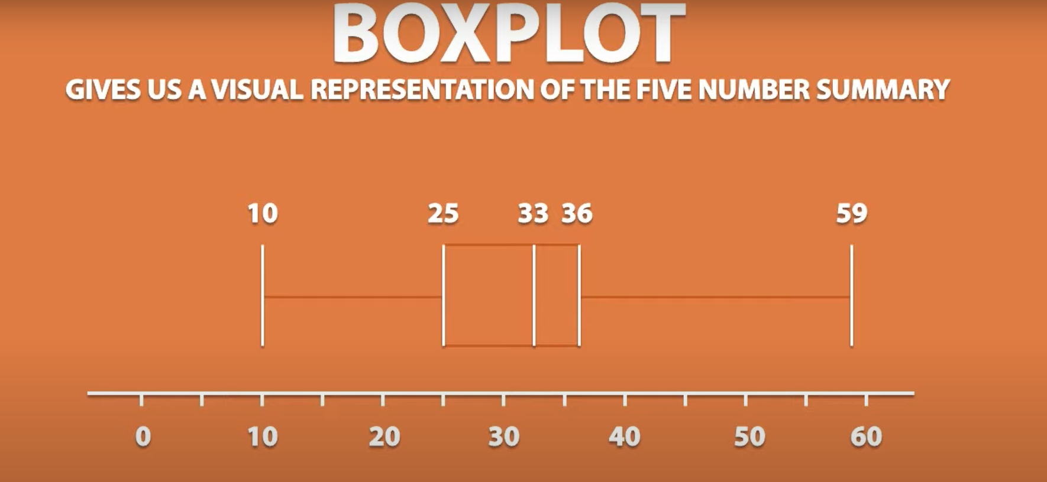

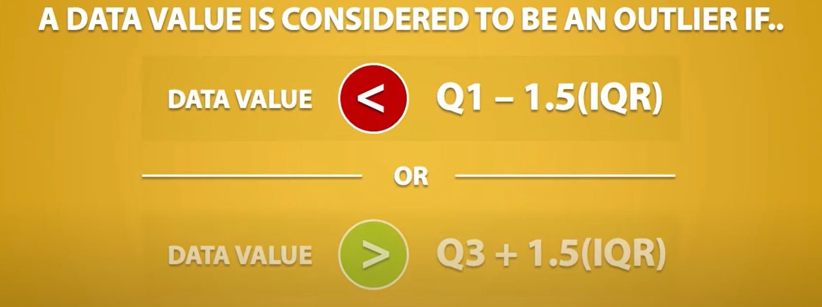



Since there is no value below 8.5 hence there is no outlier at the beginning. Though there are values in the dataset that fall after 52.5 hence that values will be considered outliers and hence 59 is marked as an outlier.

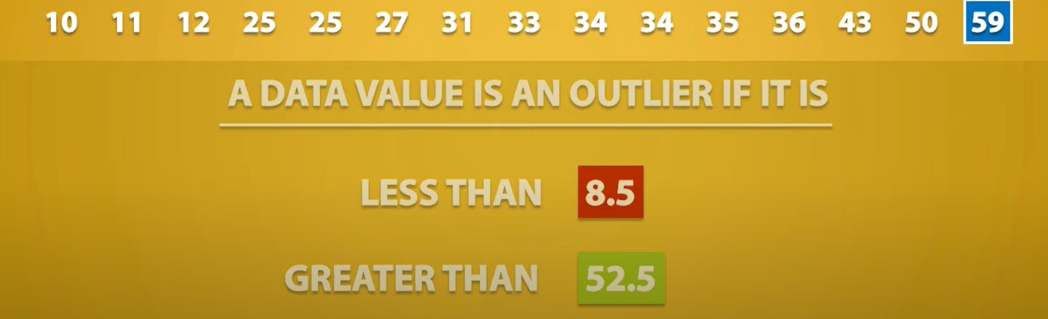

You can see the modfied box plot as below.

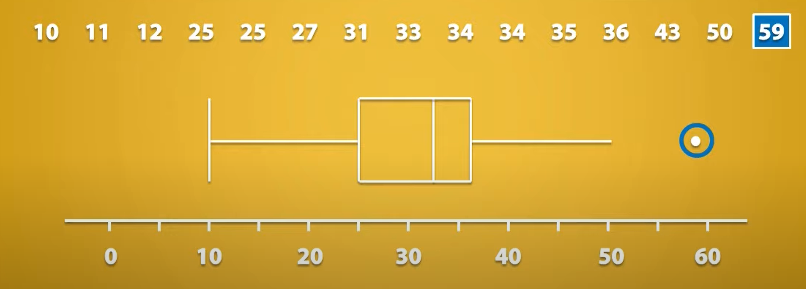

Scatter Plot:

A scatter plot is a type of graphical representation used to display the relationship between two continuous variables. Each point on the scatter plot represents a single observation or data point, with one variable plotted on the x-axis (horizontal) and the other variable plotted on the y-axis (vertical). Here are some key points about scatter plots:

